**Blockquotes are useful for quoting blocks of content from another source within your web page**  
1. <blockquote> element can be used with any HTML that you want as the quote. For simple text quotes bootstrap recomends using a <p> element.  
2. For identifying the source of the quote, use the <footer> element. Wrap the name of the source work using <cite> element. On hover the title attribute value will be displayed as a tooltip.  
3. To right-align the blockquote content, use .blockquote-reverse class on the <blockquote> element   
  
**Blockquotes example :**

<blockquote class="blockquote-reverse">

    <p>By failing to prepare, you are preparing to fail</p>

    <footer>

        This famous quote is by

        <cite title="Benjamin Franklin">

            Benjamin Franklin

        </cite>

    </footer>

</blockquote>

**Output :**   
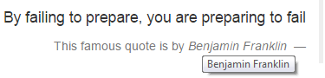  
  
**Bootstrap List tags and classes**   
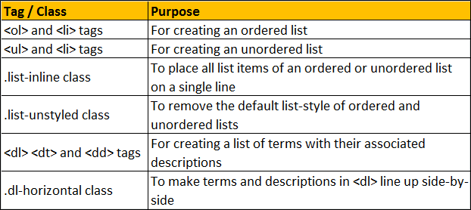  
  
**Bootstrap Ordered List :** For an Ordered List use the <ol> element

<ol>

    <li>India</li>

    <li>USA</li>

    <li>UK</li>

    <li>Australia</li>

    <li>Canada</li>

</ol>

**Output :**   
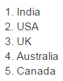  
  
**Bootstrap Unordered List :** For an Unordered List use the <ul> element

<ul>

    <li>India</li>

    <li>USA</li>

    <li>UK</li>

    <li>Australia</li>

    <li>Canada</li>

</ul>

**Output :**    
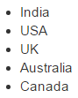  
  
To place all list items of ordered or unordered list on a single line use the **.list-inline** class

<ul class="list-inline">

    <li>India</li>

    <li>USA</li>

    <li>UK</li>

    <li>Australia</li>

    <li>Canada</li>

</ul>

**Output :**   
bootstrap list items inline  
  
To remove the default list-style of ordered and unordered lists use the **.list-unstyled** class

<ul class="list-unstyled">

    <li>

        India

        <ul class="list-unstyled">

            <li>Andhra Pradesh</li>

            <li>Tamil Nadu</li>

            <li>Kerala</li>

        </ul>

    </li>

    <li>

        USA

        <ul>

            <li>Alabama</li>

            <li>Alaska</li>

            <li>Iowa</li>

        </ul>

    </li>

    <li>UK</li>

    <li>Australia</li>

    <li>Canada</li>

</ul>

**Output :**   
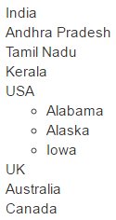  
  
For creating a list of terms with their associated descriptions use <dl> <dt> and <dd> tags

<dl>

    <dt>ASP.NET</dt>

    <dd>Framework for developing web applications</dd>

    <dt>jQuery</dt>

    <dd>JavaScript library that works across a multitude of browsers</dd>

    <dt>SQL</dt>

    <dd>The standard language for relational database management systems</dd>

</dl>

**Output :**   
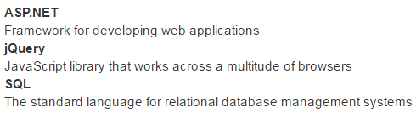  
  
To make terms and descriptions in <dl> line up side-by-side use **.dl-horizontal** class

<dl class="dl-horizontal">

    <dt>ASP.NET</dt>

    <dd>Framework for developing web applications</dd>

    <dt>jQuery</dt>

    <dd>JavaScript library that works across a multitude of browsers</dd>

    <dt>SQL</dt>

    <dd>The standard language for relational database management systems</dd>

</dl>

**Output :**   
